AVL Tree
Prerequisite : BST
Problem with BST
The disadvantage of a skewed binary search tree is that the worst case time complexity of a search is O(n)

Drawback of BST
It can be not balanced.
e.g :
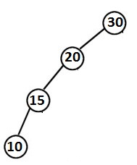
Below BST have 4 elements and height is also 4. So searching be like linear search.
In this case Time Complexity is O(n).

AV L
- There is a need to maintain the binary search tree to be of balanced height, so that it is possible to obtained for the search option a time complexity of O(log n) in the worst case
- One of the most popular balanced tree was introduced by Adelson-Velskii and Landis (AVL)

AVL Tree
• An empty binary tree is an AVL tree.
• A nonempty binary tree T is an AVL tree iff given TL and TR to be the left and right subtrees of T and h(TL) and h(TR) to be the heights of subtrees TL and TR respectively,
TL and TR are AVL trees and I h(r) - h(TR) I <= 1

Balanced Factor
- h(TL) – h(TR) is called balance factor (BF).
Above: h(TL) : height of Left Subtree and h(TR) : height of Right Subtree.
- For AVL tree the balance factor of a node can be either 0, 1 or -1.

Note : When we add new node in AVL tree we have to check balanced factor of added node and its ancestor nodes only.

Searching in AVL Tree
Searching an AVL search tree for an element is exactly similar to the method
used in a binary search tree.

Example: BST with Balanced Factor
50 , 40 , 60 , 30 , 20

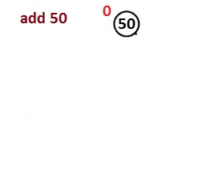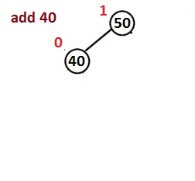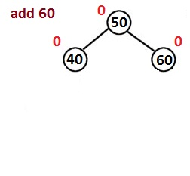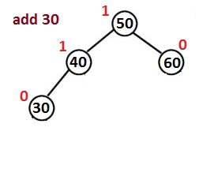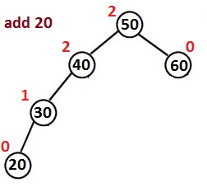
Note: Balanced factor is affected at node 40 and 50 when we add 20 in BST.

Insertion in AVL Tree
If after insertion of the element, the balance factor of any node in the tree is affected so as to render the binary search tree unbalanced, we resort to techniques called rotations to restore the balance of the search tree.

Rotation in AVL Tree

Rotation

To perform the rotations it is necessary to identify a specific node A(Problem Node) whose balance factor (BF) is neither 0, 1 or -1 and which is the nearest ancestor to the inserted node on the path from the inserted node to the root.

Rotation Types

Reason due to Unbalanced
• LL Case: Inserted node is in the left subtree of left child of node A.
• RR Case: Inserted node is in the right subtree of right child of node A.
• LR Case: inserted node is in the right subtree of left child of node A.
• RL Case: Inserted node is in the left subtree of right child of node A.
Example:

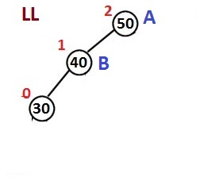 | 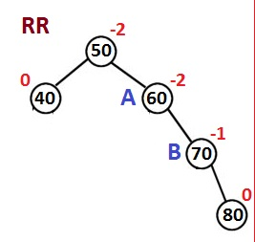
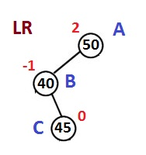 | 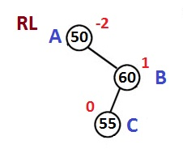

Trick to solve

• For LL and RR rotations identify A and B then make A as a child of B.
• For LR and RL rotations identify A, B and C then make A and B child of C.

Remember : A is Unbalance Node
B is next of unbalanced node which side node is added.
C is next of B node which side node is added.

Example: LL And RR Rotation
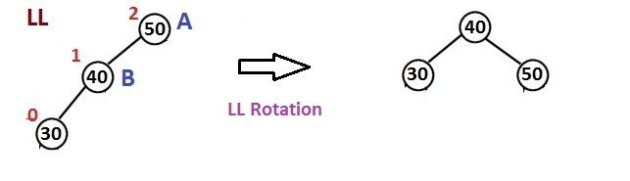
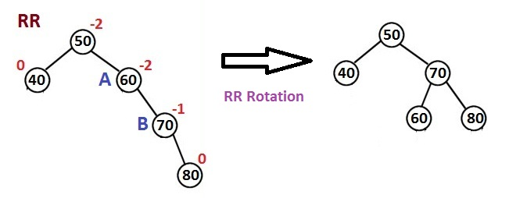

Example : LR And RL Rotation

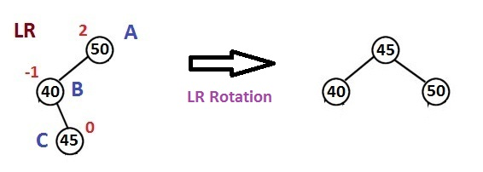
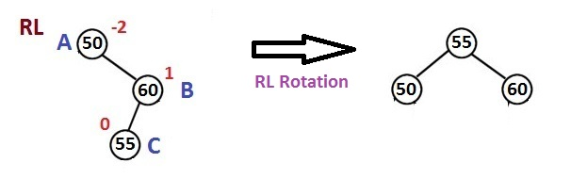

Solved Example of Rotations in AVL Tree

Generate AVL tree for the values

5 , 7 , 19 , 12 , , 10 , 15 , 18 , 20 , 25 , 23
